EXPERIMENT-18
18. A fruit-sorting machine identifies fruits based on their colours. Implement Fruit Colour Classification. Classify fruits using production rules.

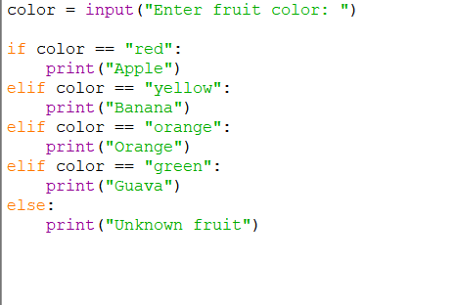
PROGRAM:

OUTPUT:


